**SQLAlchemy Homework - Surfs Up!**

**Precipitation Analysis**

Steps to analysis:

1. First we create a query to reflect the actual data, based on the tables already found “Measurement” and “Station” of the date and precipitation scores. Considering for the query the next:
   1. Retrieve the last date
   2. Calculate the data one year from the last date
   3. Retrieve the information for the date and precipitation

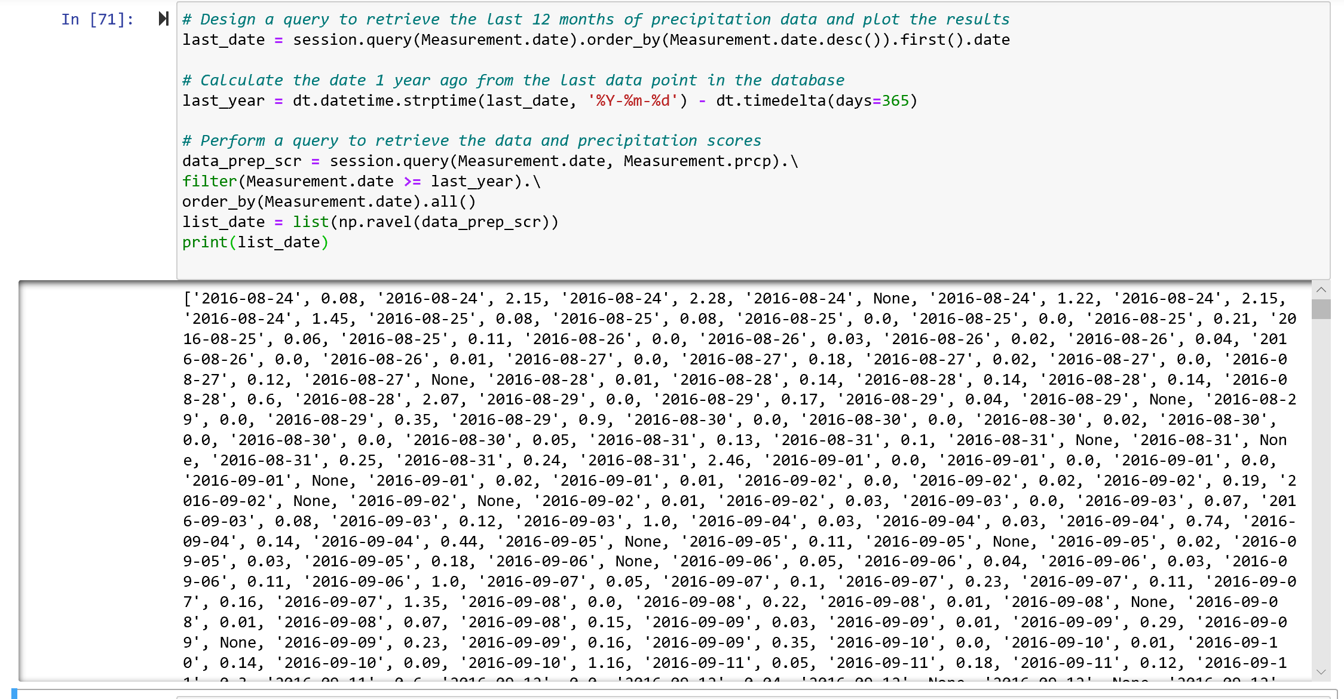

1. Once generated the query, we plot the information

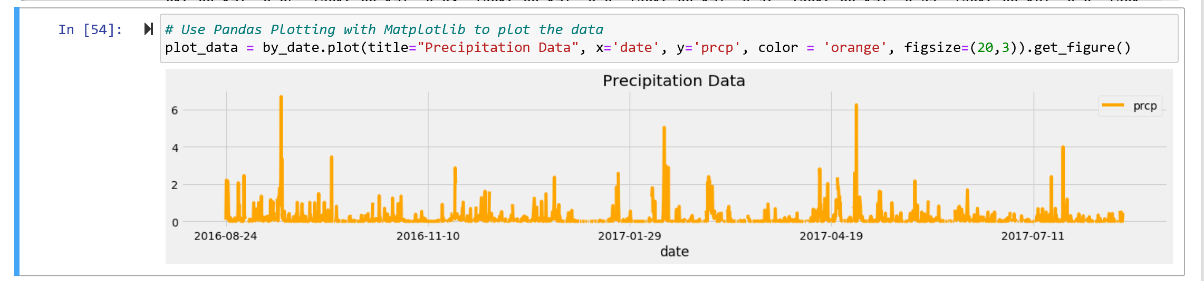

1. At least we generate the summary statistics

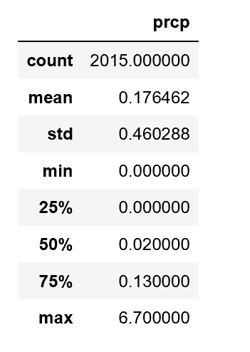

**Station Analysis**

* Design a query to calculate the total number of stations.

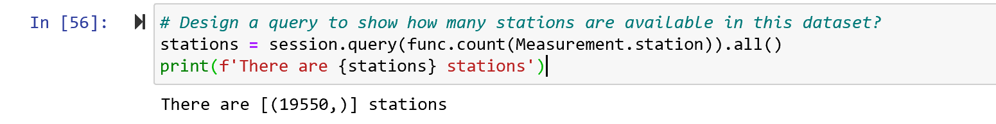

* Design a query to find the most active stations.

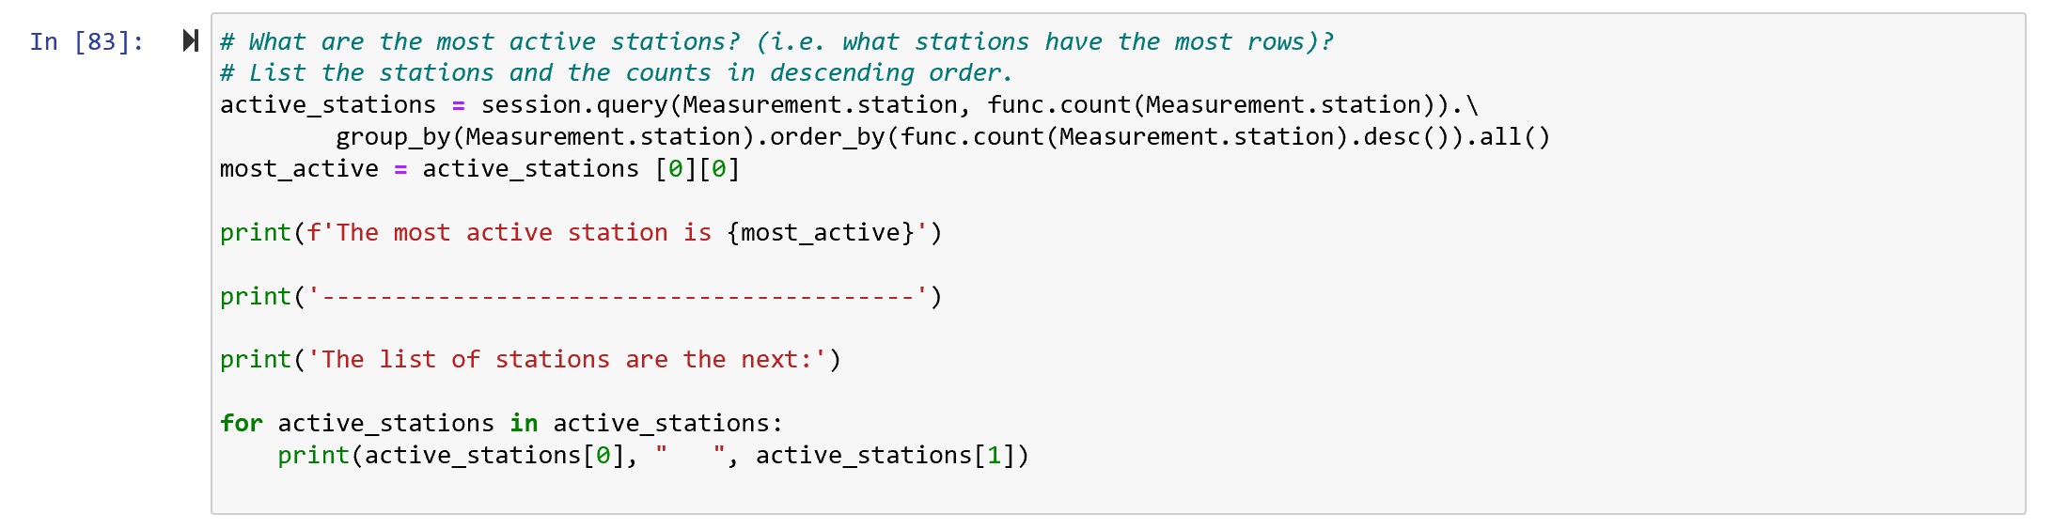

* + List the stations and observation counts in descending order.
* 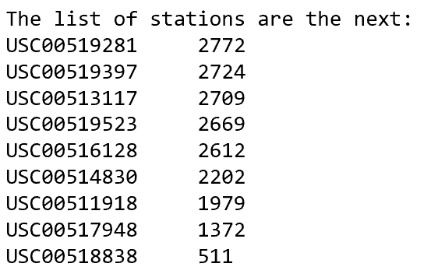
  + Which station has the highest number of observations?



* + Hint: You will need to use a function such as func.min, func.max, func.avg, and func.count in your queries.
* Design a query to retrieve the last 12 months of temperature observation data (TOBS).
  + Filter by the station with the highest number of observations.
  + Plot the results as a histogram with bins=12.

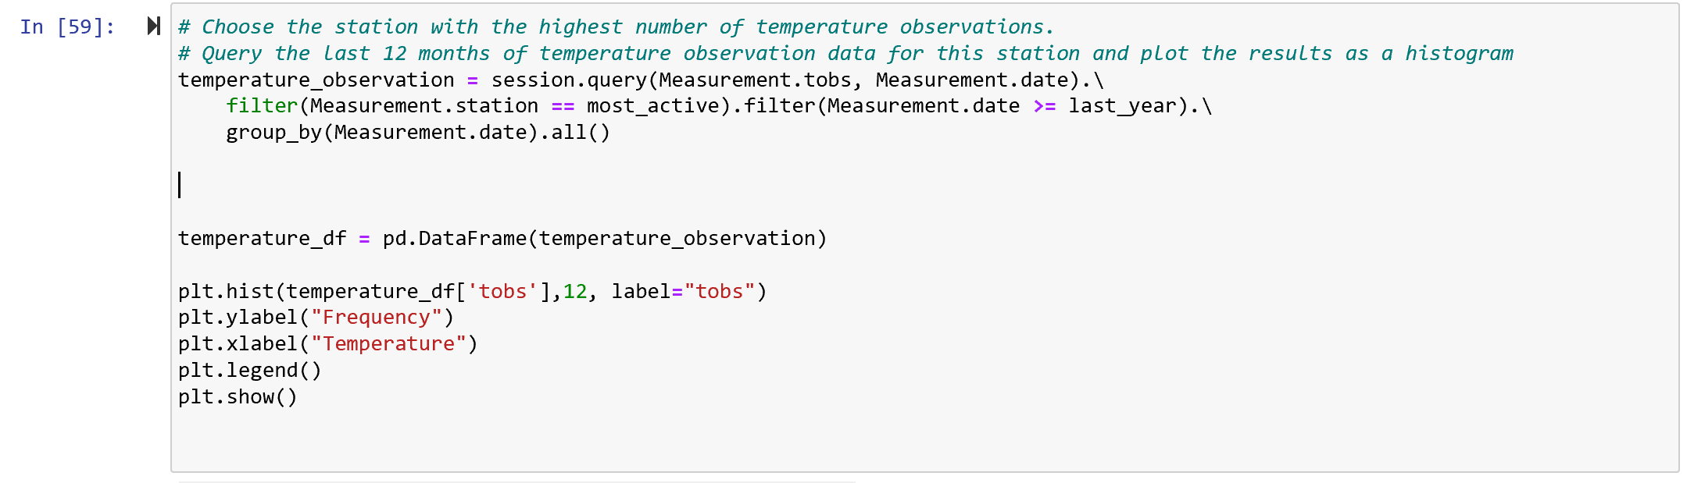

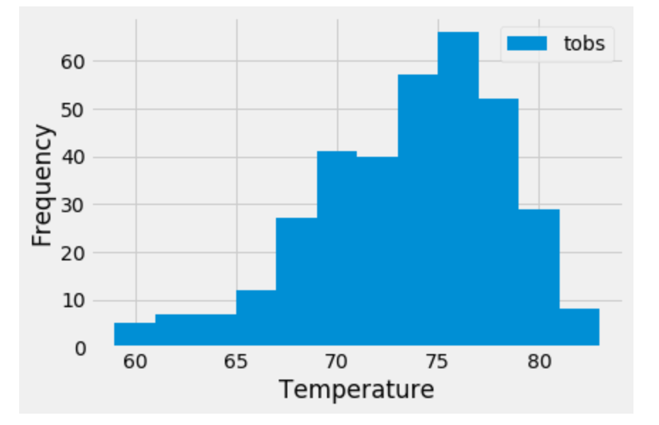

**References:**

**Funciones SQLAlchemy**

<https://www.programcreek.com/python/example/72039/sqlalchemy>

**sqlalchemy.func.count()**

<https://www.programcreek.com/python/example/72039/sqlalchemy.func.count>

**sqlalchemy.func.avg()**

<https://www.programcreek.com/python/example/88980/sqlalchemy.func.avg>

**sqlalchemy.func.max()**

<https://www.programcreek.com/python/example/78408/sqlalchemy.func.max>

**datetime**

<https://docs.python.org/2/library/datetime.html>

**Pandas**

<https://pandas.pydata.org/pandas-docs/stable/reference/api/pandas.DataFrame.set_index.html>

<https://www.analyticslane.com/2019/04/29/diferentes-formas-de-ordenar-dataframes-en-pandas/>

**Flask**

<https://flask.palletsprojects.com/en/1.1.x/>

<https://palletsprojects.com/p/flask/>

<https://www.fullstackpython.com/flask.html>

<https://realpython.com/flask-by-example-part-2-postgres-sqlalchemy-and-alembic/>